Lesson Plan: Kindness Group Art Project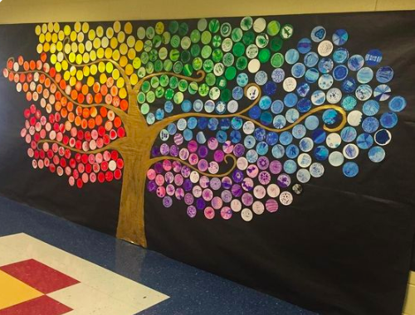

Lauren Cottle

Planet Kid: December 2019

**Objective**

* To define what kindness means to each student & list examples of how to be kind.
* To identify what a mural project is and how it can represent community.
* To identify what colors, shapes, or images come to mind when one thinks of “kindness.”

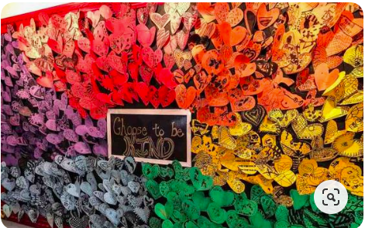

**Introduction**

* Murals can represent community goals or values. They enhance the environment by providing artwork to look at and an idea that the artwork proposes.
* Students will work together to complete their own heart (or leaf) which will be placed alongside each other to create a wall of hearts (or tree).

**Activity**

* The project will begin with a short lesson on murals and kindness (how American culture and Judaism define this value).
* Directions will be given so that students understand how the art process works.
* Instructor will show an example of a completed heart/leaf.
* Instructor will point out supplies and areas where students can work on the project.
* After the lesson and directions, students will choose a leaf and/or heart and begin coloring, constructing, and writing on their papers.
* Counselors will assist students in completing their project and answer any questions.
* After students are done completing their project, they will bring them to the front of the room where, as a group, the class will paste each paper onto the mural.
* The mural will be hung in the classroom (or hallway) area upon completion.

**Supplies**

* Multi-colored construction paper
* Markers, crayons, colored pencils
* Paper plates
* Large cardstock or poster board
* Gluesticks and liquid glue

**Topics**

* What are the values of the GJCC?
* What is a mural?
* What does kindness mean to you?

**Learning Outcomes/Assessment**

* Knowledge: Ask the students to define the words kindness, mural, and community.
* Analyze: Look at the mural and point to different leaves/words/images. What do these mean?
* Comprehend: How does this mural communicate the values of Planet Kid/JCC?
* Apply: What would someone think about or see when they pass this mural?
* Synthesize: What did we learn today? What was our goal? Have we completed our goal?